**Describe: The purchasing cycle daintily purchasing documents and their use to control food purchases (P1)**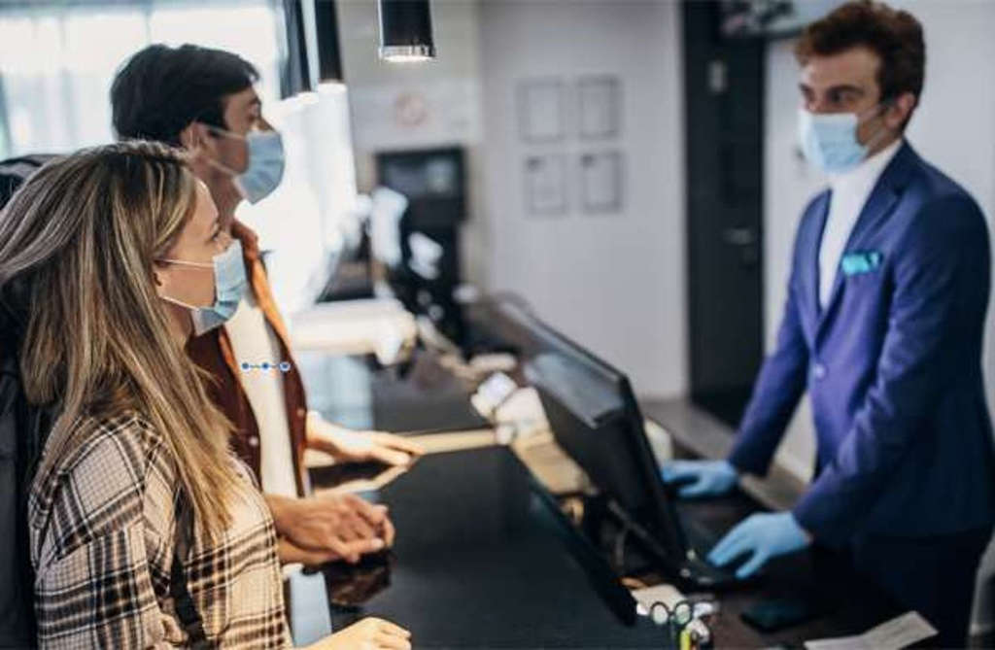

**The purchasing cycle**

* The procurement cycle is the process of selecting a vendor, buying goods or services from them, and managing their ongoing performance. Also known as the procurement life cycle, purchasing cycle, or sourcing cycle, the procurement process is, indeed, circular in most cases.

**What are the purchasing document used in the hospitality industry**

* Guest information
* Supplier information
* Staff records
* General correspondence
* Invoices
* Health and safety and maintenance records

**How food purchasing can be controlled by the purchasing document**

* Establish goals and objectives
* Keep a tight stock control
* Supplier management and keeping a good relationship with your suppliers
* Keep the purchasing department and stock management well aligned
* Analyze sales

**Btec international level 2 hospitality**

**Unit 8 : Preparing cooking and presenting dishes**

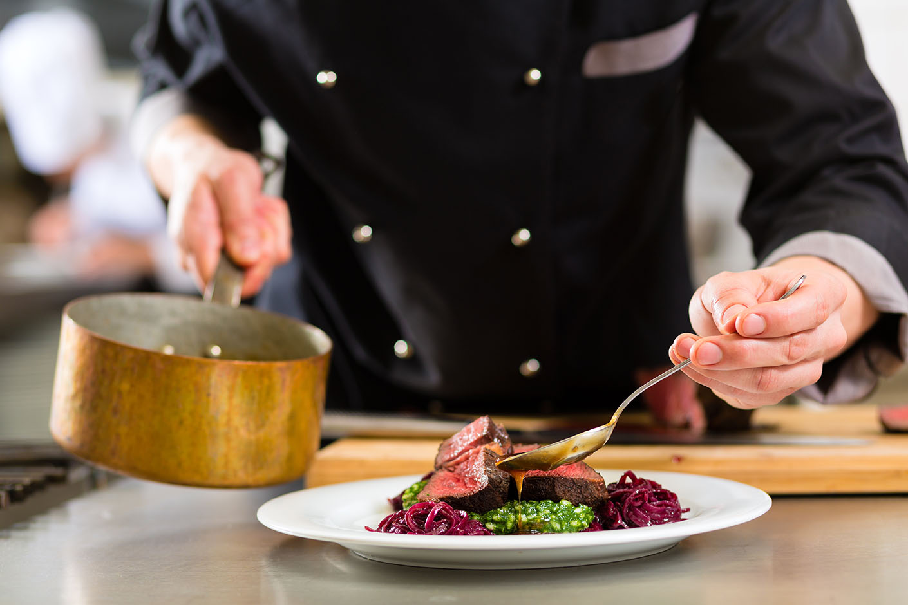

**SCHOOL: Thaajuddeen**

**CLASS: 10 btec**

**NAME: Hussain Maain**

**INDEX: 10603**